**TAS Core Usability Guide**

Version 1.0

Understanding the Human-Center Design

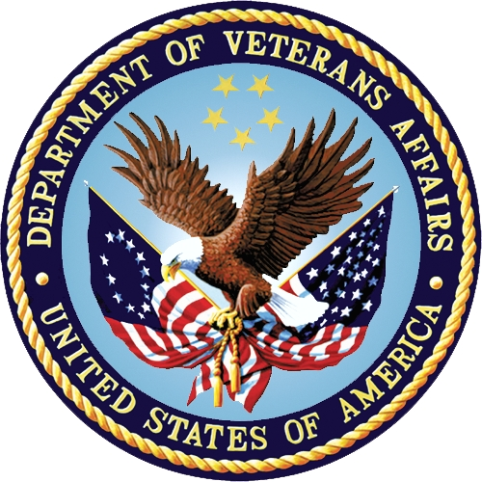

December 2017

Department of Veterans Affairs

Office of Information and Technology (OI&T)

**Revision History**

| Date | Version | Description | Author |
| --- | --- | --- | --- |
| December 2017 | 1.0 | Draft 1.0 | Douglas Weinberg |

**Artifact Rationale**

The TASCore Usability Guide is based on the human-centered design approach. Human centered design is a management framework that develops solutions to problems by involving the human perspective in all steps of the problem-solving process.

TAS Core human-centered design starts with the process of designing new solutions for people in the Veteran Affairs that are tailor-made to suit their needs. This transformational innovative approach requires a deep understanding of people that use the site. It’s all about building a deep empathy for VA users and creating new solutions for them.

The human-centered design approach is used for designing interactive systems that can be used by anyone. It must meet all VA usability and accessibility needs by applying enhanced features. These added improvements help promote user satisfaction, accessibility and sustainability to the TAS Core portal.

Table of Contents

1 Introduction 1

1.1 Human Centered Design Approach 1

1.2 Rationale for adoption 1

1.3 A double diamond approach 1

1.4 Three principles of human-centered design 4

1.5 TASCore Design Principles 4

1.6 Design Principles 4

2 Product Methodology 5

2 .1 Process 5

1.0 DISCOVER 6

Project definition 6

Kickoff 6

Discovery 7

DESIGN 8

Design 8

Design, Prototype and Plan (Alpha) 8

Iterate and Build (Beta) 9

DELIVER MEASURE REFINE 10

Deliver Measure Refine 10

Preflight 10

Go Live 11

Sunset 11

Operations and Maintenance (O&M) 12

3 Roles and Responsibilities 15

TAS Governance Committee 15

# Introduction

This document describes how the TASCore intranet portal was built using a human-centered design approach. By better understanding the needs of the users, the site was developed in response to those needs. Getting feedback from these users allowed the development team to design a portal with enhanced features so it can be accessible to all users.

## 1.1 Human Centered Design Approach

What is human centered design?  It’s a process that starts with the people you’re designing for and ends with new solutions that are tailor made to suit their needs. Human-centered design is all about building a deep empathy with the people you’re designing for; generating tons of ideas; building a bunch of prototypes; sharing what you’ve made with the people you’re designing for; and eventually putting your innovative new solution out in the world.

## 1.2 Rationale for adoption

A human-centered approach to design and develop the TASCore portal has many social benefits to both users, employers and management teams. Highly usable systems are more successful both technically and operationally.

1. It increases the productivity of end users
2. Reducing cost of training and support
3. Increases usability for wider range of people
4. Improves user experience
5. Reduces stress and discomfort
6. Improves the branding and professionalism
7. Contributes toward sustainable objectives
8. Resonates more deeply with an audience

## 1.3 A double diamond approach

Human-centered design consists of four phases:

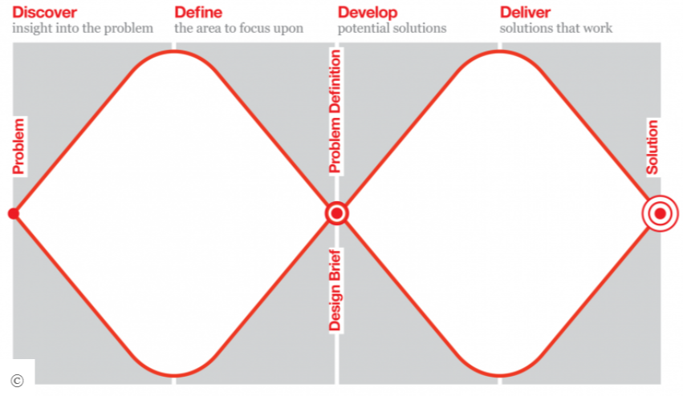

1. **Discover** – this phase is where teams work at gather insights into the problem. It seeks to gather information about the initial insight. It focuses on learning as much as possible about the VA audience and users to the TAS system. Research is conducted. User needs are synthesized and analyzed. This is the phase where teams discover insight into the problem.

**Discovery leads to divergent thinking** - individuals/teams work to collect as much information as possible about the given issue at hand. In this phase, any filtering or selectivity is minimized (if done at all) the objective is to acquire as many insights or possibilities as can be.

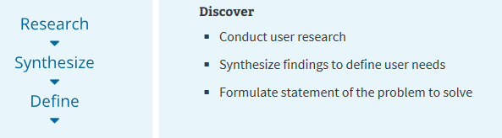

1. **Define – this phase is about convergent thinking.** Once the information has been gathered, the ‘define’ phase is next to determine how to use it. Which aspects are most important? What can be learned from it? It is up to the development team to empathize and understand the needs of their users. During this phase, the characteristics, requirements and objectives are defined into solutions. Business and technical teams can make a wide range of choices from an expanded understanding of the challenge and possible solutions. They begin to define and focus on possible end to end solutions. In the convergent phase, teams work towards decisions by examining the information gathered in the divergent phase by=prioritizing, organizing and eliminating information/options based on their objectives.

|  |  |
| --- | --- |
|  | These two thinking modes can be illustrated from left to right as two triangles. In doing so, the illustration takes on the appearance of a diamond, hence the name Diamond Model. |

1. **Develop/Design –** this is phase where solutions are designed and developed. The double diamond repeats itself. The third phase marks a period of development where TASCore solutions or concepts are created, prototyped, tested and iterated. This process of trial and error helps designers to improve and refine their ideas. This phase is also where usability and accessibility for 508 compliance come into play.

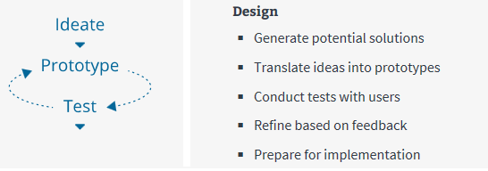

1. **Deliver/Measure/Refine** – the final phase of the double diamond model is the delivery stage, where the resulting project (a product, service or environment, for example) is finalized, produced and launched. New services and products are created in this phase through Agile methodology. New offerings are released with feedback loops. As the product is developed, it is continuously monitored and refined to increase user adoption and satisfaction.

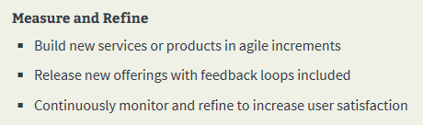

**This 4-step design approach allows for looping of one phase to the next as shown in the diagram below.**

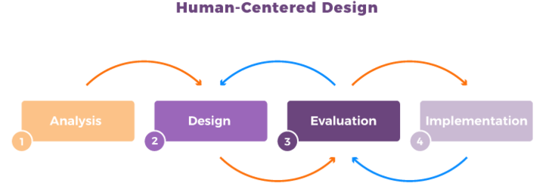

## 1.4 Three principles of human-centered design

TAS Core portal was developed using 3 principles of human-centered design. The primary goal of this project was to satisfy the needs of the VA audience in both functional and emotionally meaningful ways. The three general principles used include:

1. **Collaboration**. Collaboration through the product teams so everyone works together.
2. **Empathy**. You can’t create a product for people if you don’t deeply understand their motivations.
3. **Experimentation.** It’s only through conversations, experiments), and learning that a great product is born.

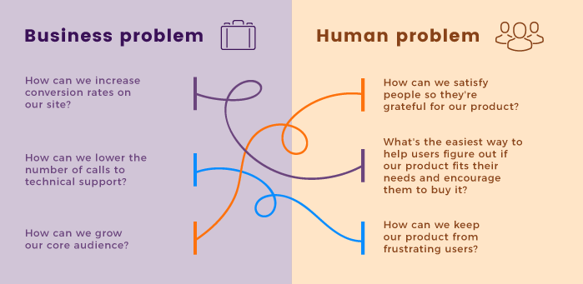

## 1.5 TASCore Design Principles

* Understand human need: design for people, rather than VA’s systems
* Assume every visitor is new.
* Speak clearly, respectfully and directly.
* Help people reach their goals every time.
* Connect with customers. Create opportunities for feedback and dialog.
* Research, observe, test and continuously improve.
* Measure what matters.
* Be device agnostic.
* Employ modern development practices – use Agile methodologies. Business units take on a functional role. Product teams take on the technical roles.

## 1.6 Design Principles

There are 5 basic principles that form the foundation for the human-centered design:

**Human centricity**: To create effective solutions, it is important to understand the challenges and opportunities that people from the VA encounter in their lives.

**Cognitive empathy**: Understanding feelings, thoughts and emotions. To create solutions that fit into people’s lives, it’s necessary to know their understandings and how they perceive specific situations.

1. **Create possibilities:** To create good design, a numerous set of different ideas must be discovered. A large pool of possible solutions can be examined, tested and organically selected.
2. **Real Outcomes:** a great desire to create great design. The outcome will be better while the objective becomes achievable. In return, good design can be measured and monitored.
3. **Iterative:** this leverages continuous learning and never really ends. The design process never ends. A solution presents an opportunity to learn from those that use it. These learnings can be used to further refine and evolve the solution.

# Product Methodology

The TASCore portal was developed using human centered design using Agile methodology that provides customer needs and support through cycles of continuous improvement.

This methodology is intended for product teams and business units to present content and UI controls for TASCore portal. It involves the process of extracting data from legacy systems such as VistA (Veterans Information Systems and Technology Architecture (VISTA) and using HAPI FIRH services to migrate that data into TASCore.

The framework is a best practice model that aligns human-centered design with the TASCore development and migration process.

The activities of each product team are detailed in each phase of the double diamond approach. Its role is to define the resource model, change model and policy model for the TASCore intranet site. It covers administration, maintenance, support and development. The framework identifies lines of ownership between the business and development teams clearly outlining the roles and responsibilities for each team member.

Secondly, the framework is used to establish rules for the appropriate usage of the TAS portal.  
This is to ensure that the system is properly managed and used in accordance to the guidelines of this document. This will help maintain manageability and improve upkeep of the portal.

## 2 .1 Process

TAS Core implements the Agile methodology along with human centered design to produce a stable portal that is continuously supported by the product teams and business units.

The methodology is used by the teams to when developing new products for the VA. The TAS Core/Agile framework is a best practice model that aligns human-centered design with TAS Core development. The activities between the business units and product teams undergo several key milestones that are accepted by VA stakeholders during each phase of the process.

|  |  |  |
| --- | --- | --- |
| **Discover** | **Design** | **Deliver, measure and refine** |

|  |
| --- |
| 1.0 DISCOVER |

## Project definition

An outline of project’s key components. This includes a description of the current environment.

**TAS Core Stakeholder Engagement**

* Complete initial TAS Core assessment
* Identify TAS Core team roles as defined in Memo of Understanding (MOU)
* Work collaboratively with all the product teams on gather business requirements
* Validate MOU

**Planning**

* Define project goals and scope
* Create initial timelines including known deadlines
* Identify resources, allocations and budget
* Identify needed service level agreements (SLAs)
* Define and assign roles
* Identify final decision makers
* Outline current technical environment and platform dependencies
* Create a project plan

|  |  |  |
| --- | --- | --- |
| **Outputs** | **Leads** | **Participants** |
| Define Project Plan | Project Team POC | Project Team POC |
| Signed MOU | TAS Core Business Owner | TAS Core Business owner |
|  | TAS Core Product Lead | TAS Core Product Lead |
|  |  | TAS Core SMEs |

## Kickoff

After the project has been defined, a kickoff meeting is conducted to assimilate a project team. The team’s goal is to shed light and shared understanding of the project’s goals, scope, milestones, roles and responsibilities. Business requirements are gathered from the business units along with user needs and technical platform dependencies.

**TAS Core Stakeholder Engagement**

* Gather the right people needed to attend kickoff meeting with a given agenda
* Work collaboratively with business units

**Team**

* Assemble the team
* Review project goals, timelines and definitions. Adjust as needed.
* Develop sprint cycles
* Review business requirements
* Review know user needs
* Review know technical platform dependencies
* Identify constraints and risks

|  |  |  |
| --- | --- | --- |
| **Output** | **Leads** | **Participants** |
| Kickoff meeting | Project Team POC | TAS Core kickoff attendees |
| Draft Project Plan | TAS Core Business Owner | Project Team POC |
|  | TAS Core Product Lead | Design Team |
|  |  | Engineering Team |
|  |  | TAS Core Business SMEs |
|  |  | TAS Core Technical SMEs |

## Discovery

This milestone validates and expands upon the project definition. This research phase helps promote a deeper understanding of the business and customer needs. Technical investigation occurs in this phase so these activities are used to help build the foundation for the new product. It’s a conceptual exploration phase.

**TAS Core Stakeholder Engagement**

* Provide business requirements, validate design concepts and provide feedback to TAS Core team
* Provide documentation and information in a timely manner
* Provide introductions/ grant access to end users
* Provide feedback about end users
* Develop and launch a communication plan
* Provide input for sunset strategy for legacy systems and content

**Engineering**

* Identify all required data elements
* Identify data collection needs and data-driven goals.
* Identify related systems, plan for rebuild or integration
* Define system architecture including data, security, integrations and services

**Search**

* Identify current user terms on TAS Core
* Identify initial keyword list

**Content**

* Define goals for content, what do users need?
* What new content needs to be created?
* Use TAS Core style guide in creating new content and revising existing content.

**Design Research**

* Create a research plan
* Conduct research, document findings
* Share with the product teams

|  |  |  |
| --- | --- | --- |
| **Output** | **Leads** | **Participants** |
| Discovery Report | Project Team POC | Architects |
|  | Project Team Leads | Engineering |
|  | TAS Product Lead | Front-end developer |
|  |  | TAS Core Product Lead |
|  |  | TAS Core SMEs |
|  |  | UX Designer |

|  |
| --- |
| **DESIGN** |

## Design

## Design, Prototype and Plan (Alpha)

This phase details the iterative design and development process. Prototypes are conceptualized, created and tested with users to validate the refine the approach.

**TAS Core Stakeholder Engagement**

* Participate in demos and provide feedback.

**Design**

* Design strategy.
* Brainstorming.
* Wireframe mockups.
* Prototyping.

**Content**

* Written example of each page.
* Refine as needed.

**Front-end**

* Prototyping.
* Front-end build.
* 508 Compliance.

**Engineering**

* Logical data flows.
* Identify new data elements.

**Engineering – Environment**

* Baseline environment defined including operating systems, database servers, web servers.
* Stand-up development environment.
* Stand-up testing environment.
* Begin work on establishing pre-prod/production environments including hosting and security.
* Develop plan to migrate existing production data.

**Testing**

* Concept testing.
* End to end automated testing.
* End to end user testing.

|  |  |  |
| --- | --- | --- |
| **Output** | **Leads** | **Participants** |
| Prototypes | Design Lead | Architects |
|  | Project Team Leads | Engineering |
|  | TAS Product Lead | Front-end developer |
|  |  | TAS Core Product Lead |
|  |  | TAS Core Content Writers |
|  |  | TAS Core Business Owner |
|  |  | UX Designer |
|  |  | Testers |

## Iterate and Build (Beta)

This beta phase continues the initiative process, increasing refinements with UX styles and functionality moving toward a fully functional portal with solid back-end integration.

**TAS Core Stakeholder Engagement**

* Participate in demos and provide feedback.

**Design**

* Design strategy.
* Brainstorming.
* Wireframe mockups.
* Prototyping.

**Content**

* Written example of each page.
* Refine as needed.

**Front-end**

* Prototyping.
* Front-end build.
* 508 Compliance.

**Engineering**

* Logical data flows.
* Identify new data elements.

**Engineering – Environment**

* Baseline environment defined including operating systems, database servers, web servers.
* Stand-up development environment.
* Stand-up testing environment.
* Begin work on establishing pre-prod/production environments including hosting and security.
* Develop plan to migrate existing production data.

**Testing**

* Concept testing.
* End to end automated testing.
* End to end user testing.

|  |  |  |
| --- | --- | --- |
|  | **Leads** | **Participants** |
| Prototypes | Design Lead | Architects |
|  | Project Team Leads | Engineering |
|  | TAS Product Lead | Front-end developer |
|  |  | TAS Core Product Lead |
|  |  | TAS Core Content Writers |
|  |  | TAS Core Business Owner |
|  |  | UX Designer |
|  |  | Testers |

|  |
| --- |
| **DELIVER MEASURE REFINE** |

## Deliver Measure Refine

## Preflight

Preflight check ensure that 508 compliance and accessibility requirements have been fully met. The business units have signed off on the product before going live.

**TAS Core Stakeholder Engagement**

* Validate requirements have been met / product is accepted.

**Activities**

* All pages have a reporting tool to analyze portal traffic.
* Performance testing.
* Integration testing.
* 508 compliance testing.
* Code is open-source and backed up in repositories.
* 100% passing code test coverage.
* Implementation of clear customer feedback mechanism.
* Launch communication plan.
* Prepare HelpDesk and VA call center information to support launch and ongoing operations.
* Develop sunset strategy for legacy systems.
* Confirm coordination activities with VA Call Center, Help Desk are complete.

|  |  |  |
| --- | --- | --- |
| **Output** | **Leads** | **Participants** |
| Go live ready product version | Design Lead | Design Team |
|  | Project Team Leads | Engineering Team |
|  | TAS Product Lead | Content Owner |
|  | TAS Business Owner | Help Desk POC |
|  |  | VA Call Center POC |

## Go Live

This is the point where TAS Core portal is ready to go live. The portal still undergoes a process of continuous improvements according to user feedback and additions of new capabilities.

**TAS Core Stakeholder Engagement**

* Deploy communications per plan.

**Team Activities**

* Product launch.
* Deploy communications on legacy systems and TAS Core portal to inform users of changes.
* Help Desk prepared to monitor issues.
* Call Center prepared to monitor issues.
* Continuous improvements.
* Assessment of success metrics/measurement.
* Sunset strategy deployed.

|  |  |  |
| --- | --- | --- |
| **Output** | **Leads** | **Participants** |
| Portal | Project Team POC | Engineering Team |
| Sunset initiated | TAS Product Lead | Design Team |
|  | TAS Technical Lead | TAS Core Product Owner |
|  |  | TAS Core Product Lead |
|  |  | VA Call Center POC |
|  |  | VA Help Desk POC |

## Sunset

Existing products will need to be retired after they are re-designed and brought into the platform. Communications to these changes should be taken so users are aware of the changes.

**Team Activities**

* Identify how user needs will be served after product sunset to ensure no data is lost and there no degradation in service.
* Communicate changes on legacy websites and TAS portal.
* Implement redirects where needed
* Protect existing data
* Retire legacy content and systems
* Monitor call center and Help Desk to support issues when legacy systems retire.

|  |  |  |
| --- | --- | --- |
| **Output** | **Leads** | **Participants** |
| Product/content retirement | Project Team POC | Business Product Owner |
|  | TAS Product Lead | TAS Content Owners |
|  | TAS Business Owner | Engineering |
|  |  |  |
|  |  |  |
|  |  |  |

## Operations and Maintenance (O&M)

Operations and maintenance is the process where a live product is sustained and enhanced. It includes maintenance cycles and continuous improvements along with defined workflows to support changes and ongoing requirements.

**TAS Core Stakeholder Engagement**

* Report bugs or issues to Help Desk.
* Request enhancements.
* Update content.

**Team Activities**

* Meet SLAs.
* Provide Help Desk support.
* Bug fixes.
* Planned maintenance.
* Unplanned maintenance.
* Software upgrades.
* Security Upgrades.
* User feedback collection and analysis.
* Design refinements.
* Content updates.
* Database updates.
* Code updates.
* UX improvements.
* COOP/Disaster Recovery (DR) Capabilities.
* Complete sunset strategy.

|  |  |  |
| --- | --- | --- |
| **Output** | **Leads** | **Participants** |
| Public product | Support Contractor | Engineering Team |
| O & M Operational Model | Support Contractor COR | Design Team |
| SLAs |  | Project Team |
| Retirement of legacy systems |  | TAS Core Product Lead |
|  |  | Business unit content writers |
|  |  |  |

**Template Revision History**

| **Date** | **Version** | **Description** | **Author** |
| --- | --- | --- | --- |
| December 2017 | 1.0 | Initial Draft | Product Team |

**2.1 Resources**

A resource structure to facilitate TAS governance are the following:

* A TASCore committee or strategy group of SMEs (Subject Matter Experts). This should be in the form of business-focused committee that’s primary purpose is decision making. The members mediate and sign-off rules and procedures for the use of the portal. The group should include business leaders, PMOs and technical leaders so continued improvements of the business can be met.
* A group of SMEs in the technical realm so they can help manage the routine operational tasks, development tasks training and support.
* A team of users that are responsible for the site content. They are users who update site information displayed on web pages.

Table : Deployment, Installation, Back-out, and Rollback Roles and Responsibilities

| ID | Team | Phase / Role | Tasks |
| --- | --- | --- | --- |
| 1 | TAS Governance Committee | Business/Tech/Admin | Decision Making |
| 2 | eInsurance | Business | Maintain content |
| 3 | ePharmacy | Business | Maintain content |
| 4 | eBilling | Business | Maintain content |
| 5 | ePayments | Business | Maintain content |
| 6 | Non-MCCF | Business | Maintain content |
| 7 | NPI | Business | Maintain content |
| 8 | Developers | Technical | Develop and support |
| 9 | Administrators | Administrative | Maintenance and support |

# Roles and Responsibilities

Identifying roles and responsibilities help set boundaries and responsibilities to everyone working on the TAS portal. It is important to define these roles so everyone is aware of his/her responsibility to portal support.

## TAS Governance Committee

* + Features in the roadmap
  + Evaluating objectives
  + Defining rules and processes
  + Assigning roles and responsibilities
  + Producing a report for the Management Committee (VA business units)

This governance committee should meet once a quarter in order to evaluate and requests for changes, new features, defining new roles, etc.

Stakeholders of the governance committee must be identified. Members of this committee should consist of higher management and higher technical leads from each of VA’s TAS business units.

|  |  |  |  |
| --- | --- | --- | --- |
| **ID** | **Roles** | **Responsibilities** | **Name** |
| 1 | Governance Committee | * Assign TAS roles and responsibilities * Evaluate objectives * Define rules and processes * Product quarterly report for each business unit |  |
| 2 | Architects/Admins | * Administration   + Azure * Maintenance   + Software * Hardware |  |
| 3 | Business Layer Team |  |  |
| 4 | Development Team Lead | * Provide solution estimate * Design, develop and maintain TAS portal * JavaScript, TypeScript, Node JS, GIT Bash, CSS |  |
| 5 | Content owners | * Update web page content for each VA business unit. |  |